

<Name of Software Application>

CS 465 Project Software Design Document
Version 1.0
Megan Armstrong

Table of Contents

CS 465 Project Software Design Document 1
Table of Contents 2
Document Revision History 2
Instructions 2
Executive Summary 3
Design Constraints 3
System Architecture View 3
Component Diagram 3
Sequence Diagram 4
Class Diagram 4
API Endpoints 4
The User Interface 4

Document Revision History

Version | Date | Author | Comments
1.0 | <mm/dd/yy> | <Your Name> | <Brief description of changes in this revision>

Instructions

Fill in all bracketed information on page one (the cover page), in the Document Revision History table, and below each header. Under each header, remove the bracketed prompt and write your own paragraph response covering the indicated information.

Executive Summary

To deliver a highly scalable, stable, and secure digital platform for Travlr Getaways, the application utilizes a decoupled Model-View-Controller architecture built upon the unified MEAN stack. This full-stack JavaScript pipeline ensures that data transitions seamlessly from the cloud-based data repository directly to the user’s web browser, maximizing processing performance, reducing server strain, and allowing for fast updates to package listings. The software ecosystem is split into two distinct, interconnected interfaces to satisfy contrasting operational requirements. The customer-facing frontend operates on server-side rendering powered by the Express framework and the Handlebars template engine dynamically compiles lightweight HTML pages filled with live travel package listings, ensuring maximum search engine visibility and immediate initial load times. Conversely, the administrator portal operates as a client-side Angular single-page application designed for internal workflows, communicating asynchronously with an underlying RESTful API to allow administrators to perform secure creation, retrieval, modification, and deletion tasks on itinerary data without triggering full page updates.

Design Constraints

Building the web-based Travlr Getaways application involves several technical and architectural boundaries that define development guardrails and establish structural trade-offs throughout the development lifecycle. The mandate to develop exclusively within the MEAN stack dictates that the entire codebase across the database layers, routing rules, and user interfaces must use JavaScript or TypeScript. While this modernizes development and prevents language fragmentation, it creates a boundary that restricts the engineering team from integrating legacy backend libraries or tools written in alternative environments like Python, Java, or PHP. Maintaining two distinct architectural frontends introduces a separation of concerns that requires careful maintenance. Because the public customer-facing interface relies on server-rendered layouts and the secure admin system runs as a client-side rendered application, developers must build and maintain comprehensive API documentation to ensure that identical data objects map uniformly across both environments. Utilizing MongoDB as the persistent storage layer introduces structural boundaries since it is an inherently non-relational, document-oriented database. Complex relational schemas outlined in client wireframes, such as linking specific customer accommodations or regional excursion excursions directly to general travel packages, cannot rely on native database joints and must instead be handled explicitly via application-level object referencing or embedded sub-document structures. Because the public, customer-facing portion of the web application functions using stateless server-rendered requests, tracking live user actions across different pages presents a technical boundary. Unlike client-side frameworks that hold active memory in a global state, this architecture must use explicit session tokens, localized database lookups, or cookie configurations to preserve user preferences or trip filtering histories across routing states.

System Architecture View

Component Diagram

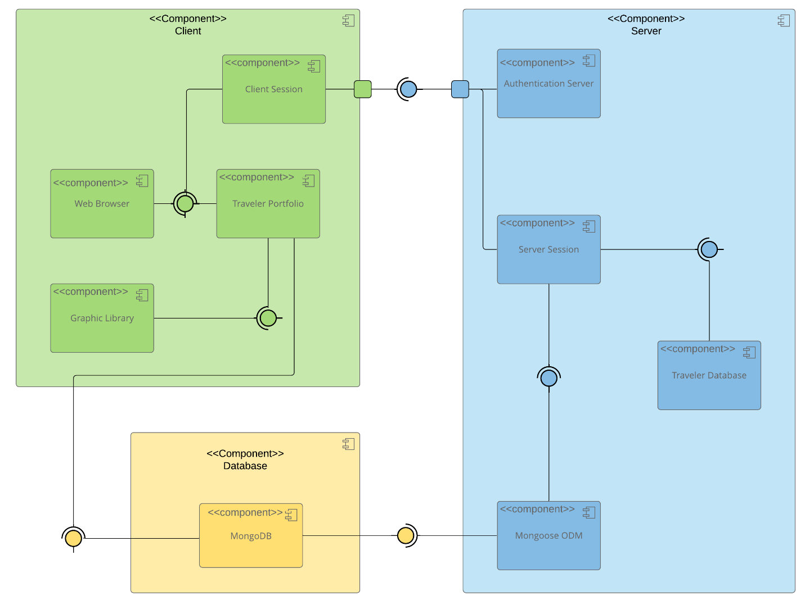

A text version of the component diagram is available: CS 465 Full Stack Component Diagram Text Version.

The structural architecture of the Travlr Getaways full-stack application utilizes a multi-tiered environment that strictly isolates presentation logic, network control flow, and persistent data storage. Data requests flow downward from user-facing screens into an application processing layer, which validates permissions and makes transactional requests to the underlying database engine before formatting and returning information to the user. The presentation tier functions as the primary collection point for user interactions and is split by target audience. The public consumer browser requests pre-compiled web documents directly from the application engine, whereas the administrative dashboard pulls an independent bundle that executes application processes directly within the browser, making narrow data calls only when transforming back-end records. The Express application and Node runtime environment act as the centralized traffic control mechanism for the entire software suite. This component intercepts inbound browser traffic via explicitly mapped RESTful API endpoints, determines whether a request demands server-side layout compilation or asynchronous data serialization, communicates with the data adapters, and manages security policies. The foundational database component relies on MongoDB to house raw enterprise assets securely within unstructured collections. It uses a Mongoose abstraction layer to bind schemas to data inputs, providing structure to non-relational files and validating data properties before formatting records into uniform JSON sets for delivery back up to the routing and presentation systems.

Sequence Diagram

<Illustrate the flow of logic in a web application by completing a sequence diagram. Insert an image of the sequence diagram here.>

<Describe the flow of logic in the web application based on the sequence diagram. Be sure to describe the interactions between the layers, or tiers, of the full stack application. It will be helpful to include significant processes such as Sign In, Trips, and Admin interactions when referring to the sequence diagram.>

Class Diagram

<Illustrate the JavaScript classes of the web application by completing a class diagram for the web application. Insert an image of the class diagram here.>
<Describe the JavaScript classes of the web application based on the class diagram.>

API Endpoints

<Exposing RESTful endpoints is a design approach to enable an application to participate in a larger ecosystem. Document each endpoint in the table below, including the HTTP method, purpose, URL, and notes.>

Method | Purpose | URL | Notes
GET | <Retrieve list of things> | </api/things> | <Returns all active things>
GET | <Retrieve single thing> | </api/things/:thingId> | <Returns single thing instance, identified by the thing ID passed on the request URL>

The User Interface

<Insert screenshots from the development of the SPA development to show the following: (1) a unique trip, added by you, (2) the Edit screen, and (3) the Update screen.>

<Summarize the Angular project structure and how it compares to the Express project structure. Be sure to describe the rich functionality provided by the SPA compared to a simple web application interaction. Describe the process of testing to make sure the SPA is working with the API to GET and PUT data in the database.>

